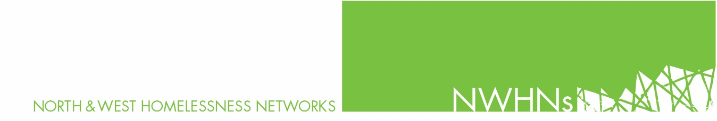
Information Sheet: January 2020
‘Crisis in Crisis’ campaign and embargo of rooming house provider
Action
From 1st March 2020 the Northern and Western Homelessness Networks will place an embargo on referrals to one of the private accommodation providers, variously known as SLM, DS Leasing, North West Accommodation and McDON.
We will not be referring anyone to facilities managed by this group. Homelessness services will work to assist any current residents of this group, who present to homelessness access points, to find alternative accommodation.
Why have homelessness services used rooming house accommodation?
Because there are no other options. As homelessness rises, crisis beds and shelters are full to overflowing, and registered rooming houses and motels are the only options left.

Homelessness services have sought to refer only to registered rooming houses, However, in many cases, services refer clients to a registered rooming house, and the client is intercepted by the landlord who redirects them to an illegal rooming house.

There are only 423 official crisis beds in the entire state, and 82,000 Victorians waiting for social housing. In one year alone, the Northern and Western Homelessness Networks had to make 10,000 referrals to emergency accommodation. No wonder rooming houses are booming.

The question we should be asking is why have Governments neglected to provide enough safe, affordable accommodation for people who have been pushed out of the private rental market. Illegal rooming houses are a symptom of a broken housing system.

According to the AIHW, 1-in-3 people seeking help are turned away from homelessness services due to the lack of accommodation.

Why an embargo?
The Northern and Western Homelessness Networks launched ‘’A Crisis in Crisis – the appalling state of emergency accommodation in Melbourne’s north and west report” in February 2019. Link: http://www.nwhn.net.au/admin/file/content2/c7/A%20crisis%20in%20crisis%20doc%20final%20040219_1550142202053.pdf

The report drew on consumers’ experiences of emergency accommodation (low-end hotels and private rooming houses), which the Homelessness Service System are completely dependent on using to house people who have nowhere to live. As anticipated the consumer experience of these places was devastating.

Women reported that it was “horrible”, “terrible” that they feared violence and rape (one woman reported a rape in a rooming house). Similarly, men reported that it was “difficult” “overcrowded”, “scary”, “impossible to cook”, “violent”.

Throughout 2019, the Networks advocated to the Department of Health and Human Services and all tiers of government, for the creation of appropriate emergency accommodation options for the thousands of people presenting to the homelessness service system each year with nowhere to live.

The Networks undertook a rating exercise in 2019 - rating the facilities that we refer/ HEF consumers to, against the amenities that consumers have identified as important in appropriate emergency accommodation.

The private accommodation provider, variously known as SLM, DS Leasing, North West Accommodation and McDON rated extremely poorly. Their facilities do not meet even basic expectations. The Networks have therefore made the decision to continue our “Crisis in Crisis” campaign with an embargo of facilities managed by these providers.

Outcomes
The embargo does not have an end date, as we do not anticipate the provider will upgrade their facilities to a reasonable level.
The Northern and Western Homelessness Networks will continue to advocate to State and Federal Members of Parliament - seeking a response to the housing crisis overall and to the lack of appropriate emergency accommodation in particular.
We need:
- a significant increase to affordable housing
- better quality purchased emergency accommodation
- more outreach resources for people in emergency accommodation to support them to exit homelessness.

Protecting consumers and homelessness workers
Providers of these facilities have been aggressive towards homelessness workers and consumers in the past. In order to protect consumer and staff throughout the embargo, the Northern and Western Homelessness Networks will be not be publicly naming specific providers but will be promoting the fact that, as Networks, we will not be referring consumers to accommodation that we do not believe meets appropriate standards.

Request
- That you join us/support us in our campaign.
- That you explain the rationale for the boycott to consumers.
- That you raise the issues with your funding provider and discuss the issues with your local Members of Parliament.
- That you support the boycott and not refer consumers to any SLM, DS Leasing, North West Accommodation (NWA) and McDON facilities.

If you would like any further information, please contact:
Meredith Gorman 0424 112 445
or
Sarah Langmore: sarah@wombat.org.au (0407 832 169)

