The following checklist provides recommended steps to support the assignment of MARAM roles and responsibilities for engaging with people who use violence (PUV).
Anticipated timeline:
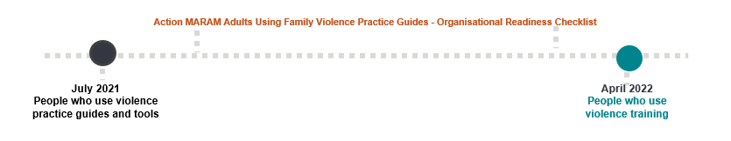
As shown in the timeline, there is an anticipated gap of approximately 10 months between the release of the PUV Practice Guides and delivery of PUV training.
It is recommended that purposeful steps are taken by organisations during this period to prepare staff members for any changes in their practice required to align with the MARAM guidance and tools. It is not recommended that staff members use the MARAM Adults Using Family Violence Practice Guides before they have received training.
The steps suggested below are reflective of a change management process, but are not prescriptive. They are intended to prompt organisational leaders to analyse, reflect and appropriately plan for the embedding of these guides and tools into practice.
Organisational leader’s checklist
- Be familiar with the adult PUV Practice Guide contents | Those responsible for MARAM alignment, and MARAM champions or team leaders should read and understand the adult PUV Practice Guides and reflect on the context for the organisation.
- Determine staff responsibilities | Use the updated MARAM Responsibilities: Decision Guide for Organisational Leaders, knowledge gained from reading the adult PUV Practice Guides and the list of MARAM responsibilities in Pillar 3 to determine staff responsibilities.
- Create a communication plan | □ Plan when and how to communicate to staff about embedding the adult PUV Practice Guides into practice.  □ Consider when to share the MARAM Practice Guides FAQ and video with staff.  □ Consider when to share the MARAM adult Perpetrator Practice Guides.  □ Promote regular and ongoing conversations about MARAM alignment with staff (including messaging that change is occurring over time).
- Map your policies and procedures – and update those already in use | □ Identify and review existing organisational policies, procedures, practice guidance and tools that will need updating to align to the MARAM adult Perpetrator Practice Guides.  □ Develop new policies, procedures, practice guidance and tools as required. This may include:  □ Intake and assessment processes / forms  □ Manuals e.g. induction, practice, training manuals  □ Record keeping obligations  □ IT systems e.g. Client Relationship Management (CRM) systems, reporting systems  □ Referral pathways including for secondary consultations (building lists and relationships in local areas and beyond for referral and secondary consult, as well as guidance for staff about who to refer/consult with and when)  □ Workplace support policies and procedures
- Develop a training strategy | □ Assess the training needs of staff. This will include identifying appropriate MARAM training against responsibilities (ready for when it becomes available).  □ Consider whether staff members require refreshing foundational knowledge of family violence, understanding of information sharing, and intersectionality.  □ Ensure all necessary staff members have undertaken MARAM Leading Alignment training for organisational leaders  □ Consider including continued support to flesh out concepts and increase capability from foundational knowledge (e.g. focusing on one specific topic at a time and allow time for staff to action any learnings and reflective practice).

The table below sets out actions which you may want to consider including in communications for staff members to undertake. It is recommended these communications are staggered over a period of time to avoid feelings of being overwhelmed.
Staff checklist
- Keep informed | Read communications and intranet updates about the reforms
- Key reading and core knowledge | Reading and viewing the following before attending training  □ The updated Foundation Knowledge Guide – Guidance for professionals working with child or adult victim survivors, and adults using family violence  □ MARAM Practice Guides FAQ  □ MARAM Practice Guides video
- Refresh your Information Sharing training | □ Refresh your information sharing knowledge, thinking about this in the context of your work with people using violence  □ Refresh your knowledge of what is ‘risk relevant’ when sharing information, particularly the evidence-based risk factors
- Understand your role | When you have been notified of your MARAM Responsibilities read the relevant guides.
- Undertake MARAM PUV training | Register and attend MARAM PUV training (once available)

For more information on MARAM, Practice Guide resources, and training visit https://www.vic.gov.au/maram-practice-guides-and-resources

