Victorian 2022 State Election
Advocacy Toolkit

The months leading up to the Victorian 2022 State Election are a perfect time to speak to your local candidates about family violence prevention and response.
Safe and Equal has launched its Victorian Election Platform, with five key priorities, to ensure that every person experiencing family violence can access the support and safety they need, when they need it, and ultimately prevent this violence from occurring in the first place.
Here’s how you can advocate for these commitments before 26 November.

Contact your local state representative and other local candidates

There are a few ways that you can make contact with your local state representatives and other local candidates. If you’re unsure who is running in your electorate, conduct some research into who your local candidates are (for example, lists such as these are a helpful way to see who may be running). You can also find information on current MPs through the Parliament of Victoria website.
Write to them
Writing an email or letter to your local candidate highlighting your experiences and the issues most important to you is a great way to raise their awareness of what’s needed to prevent and respond to family violence in Victoria. If you’re stuck for words, feel free to use some or all of the following text:
Dear (insert name of candidate)
I live in (insert name of electorate) and am calling on you to take action against family violence in the leadup to the 2022 Victorian election.
Ending family violence is complex. Even with the incredible investment into improving Victoria’s response to family violence in recent years, barriers and gaps still exist.
Along with Safe and Equal, Victoria’s peak body representing specialist family violence services, I want all parties to commit to these five key priorities ahead of the election:
- Investing more in specialist family violence services to meet escalating demand
- Growing, developing, and retaining specialist workforces
- Eliminating the impossible ‘choice’ between violence and homelessness
- Addressing system gaps and barriers to make services accessible for all
- Investing meaningfully into primary prevention
Safe and Equal’s Election Platform sets out what’s needed in each of these areas.
Will you commit to addressing these issues to ensure every Victorian has the chance to live free from family violence?
With kind regards,
(insert your name)

Join the call on social media
Sharing what's important to you on your social channels (and tagging your local candidates) is also a valuable way to raise awareness. Feel free to use and share the following content:

Short-form captions
Change takes time. To end family violence, Safe and Equal calls for a continued focus on family violence and investment in the specialist sector in their 2022 Victorian Election Platform: https://bit.ly/change_takes_time
---
To end family violence, we need ongoing investment into chronically under-funded services that are struggling with escalating demand.
Read more here: https://bit.ly/change_takes_time
---
To end family violence, we must prioritise the growth, development and retention of our specialist workforces.
Read more here: https://bit.ly/change_takes_time
---
To end family violence, we must eliminate the impossible choice between violence and homelessness.
Read more here: https://bit.ly/change_takes_time
---
To end family violence, we need to address system gaps and barriers to make services accessible to all.
Read more here: https://bit.ly/change_takes_time
---
To end family violence, we must invest meaningfully into primary prevention - because all violence is entirely preventable.
Read more here: https://bit.ly/change_takes_time

Long-form caption
Ending family violence is complex. It requires coordinated focus across all levels of our community and all aspects of family violence prevention and response systems.
Change takes time. To end family violence, Safe and Equal calls for a continued focus on family violence and investment in the specialist sector in their 2022 Victorian Election Platform: https://bit.ly/change_takes_time

Download the social media tiles below:
- Instagram
- Twitter/LinkedIn

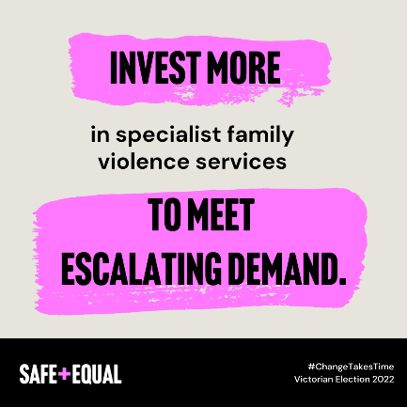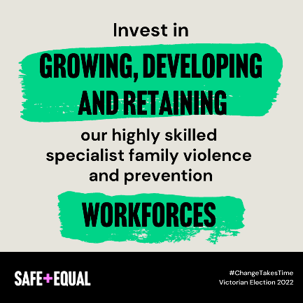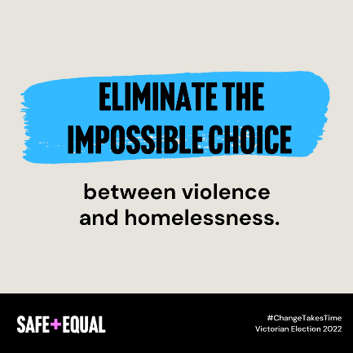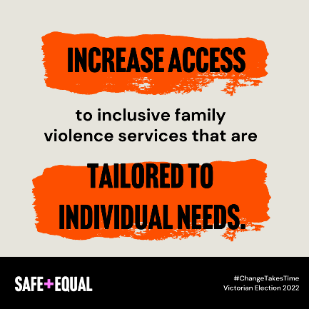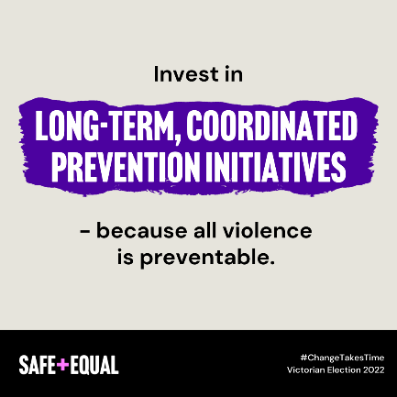
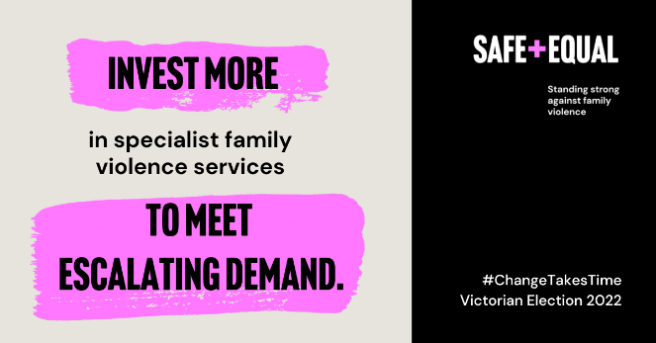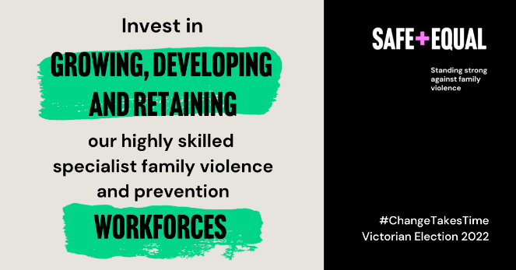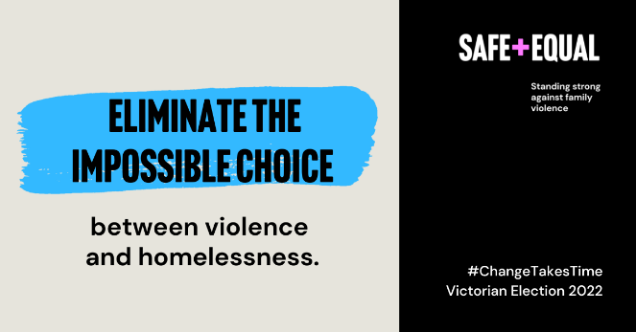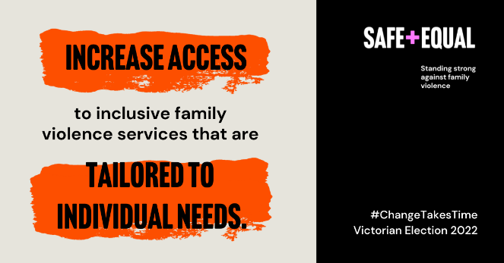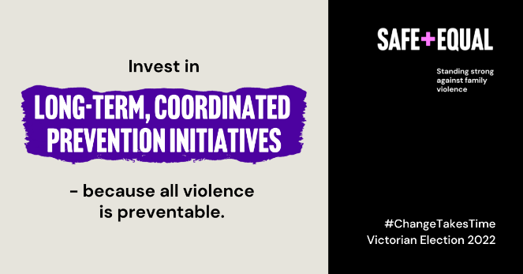

About Safe and Equal
Safe and Equal is the peak body for specialist family violence services that provide support to victim survivors in Victoria. Our vision is a world beyond family and gender-based violence, where women, children and people from marginalised communities are safe, thriving and respected.
safeandequal.org.au
https://www.facebook.com/safe.and.equal.vic
https://www.linkedin.com/company/safe-and-equal/
https://twitter.com/safe_and_equal
https://www.instagram.com/safe_and_equal/

Get in touch
If you have any questions about our Election Platform, email us communications@safeandequal.org.au.

